PHASE 5: PROJECT DEVELOPMENT PHASE

This is the main implementation phase.

5.1 Create Update Set

Navigation:

All → System Update Sets → Local Update Sets

Create:

Name: Project Update Set
State: In Progress
Application: Global

Click:

Make This My Current Set

5.2 Create Custom Table

Navigation:

All → System Definition → Tables → New

Create:

Label: Incident Workflow

Disable:

Create Module

Enable:

Auto Number

The table is used to store school IT support tickets.

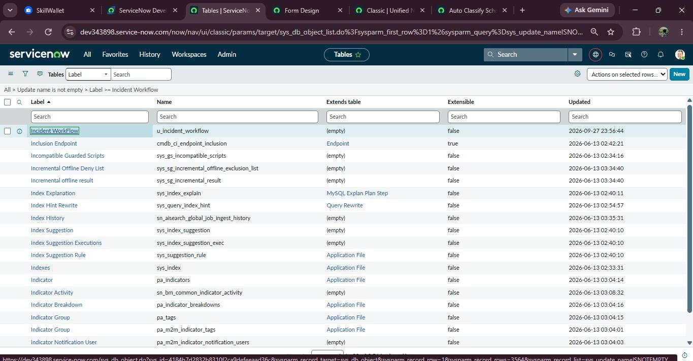
Fig 5.1

5.3 Create Fields

Create the following fields:

Field | Type
Number | Auto Number
Caller | Reference-sys_user
Category | Choice
Subcategory | Choice
Short Description | String
Description | String
State | Choice
Assigned Group | Reference-sys_user_group
Assignment To | Reference-sys_user

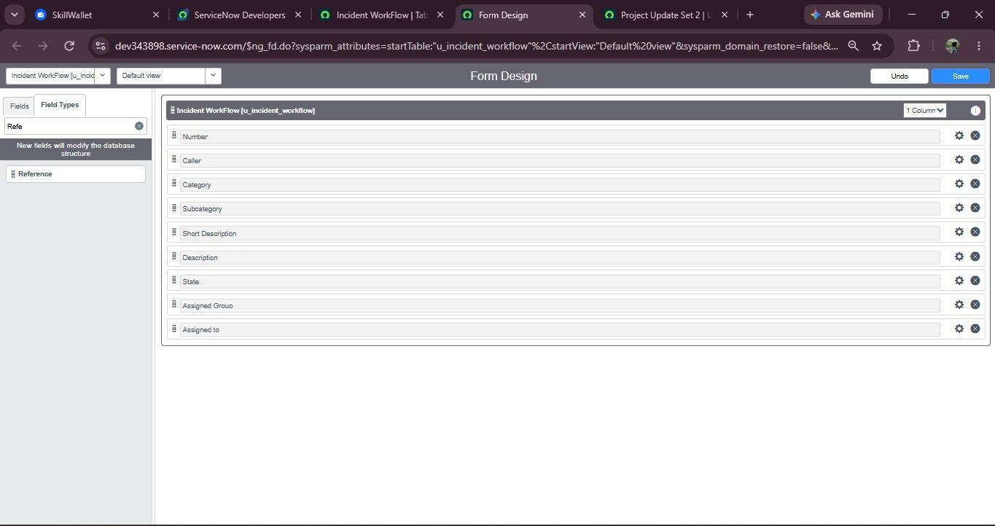
Fig 5.2

5.4 Configure Choice Values

Category

- Network
- Hardware
- Access
- Performance

Subcategory

- Wi-Fi
- Projector
- Forgot Password
- Slow Computer

State

- New
- In Progress
- On Hold
- Resolved
- Closed

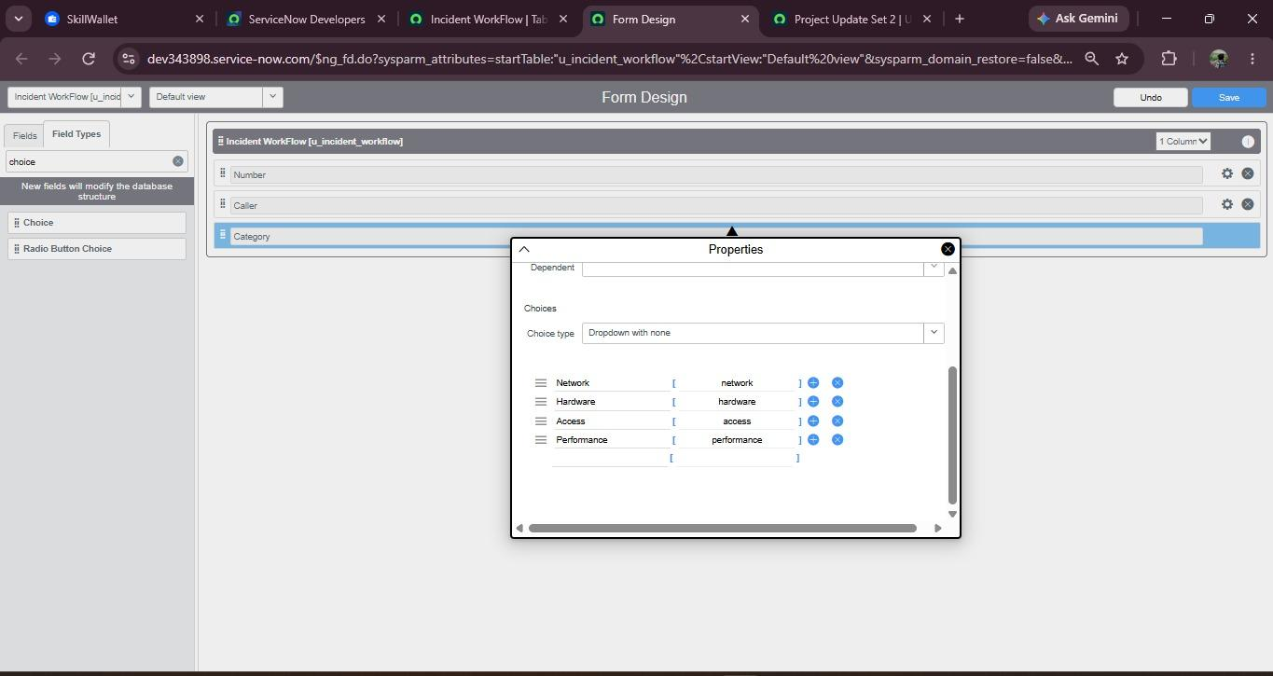
Fig.Catagory
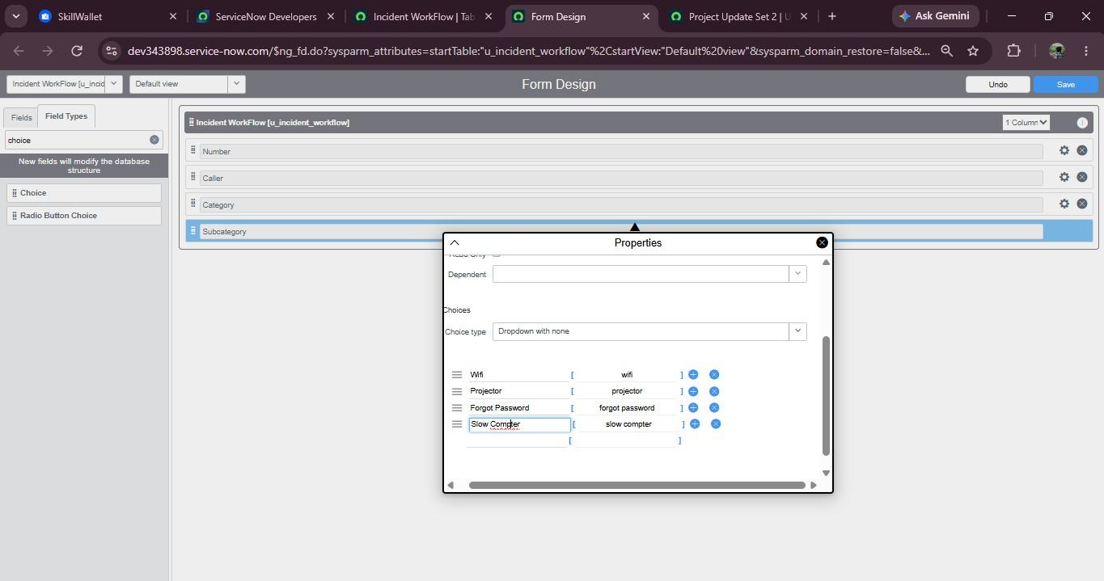
Fig.Subcategory
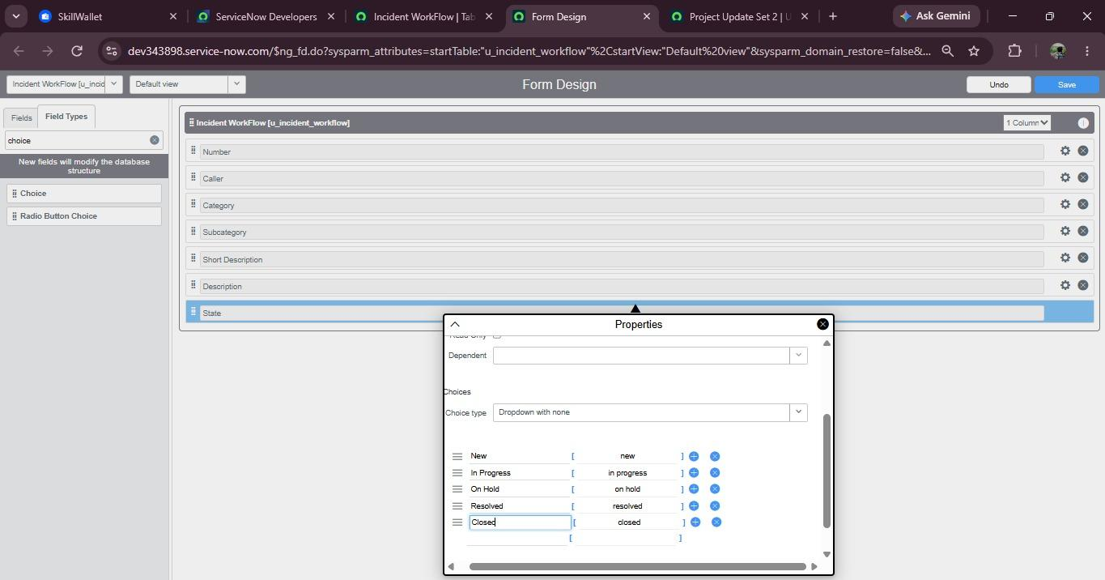
Fig.State

5.5 Configure Dependent Choice

Configure Subcategory as dependent on Category.

Navigation:

Subcategory → Configure Dictionary → Advanced View

Enable:

Use dependent field

Select:

Dependent on = Category

Configure:

Wi-Fi → Network
Projector → Hardware
Forgot Password → Access
Slow Computer → Performance

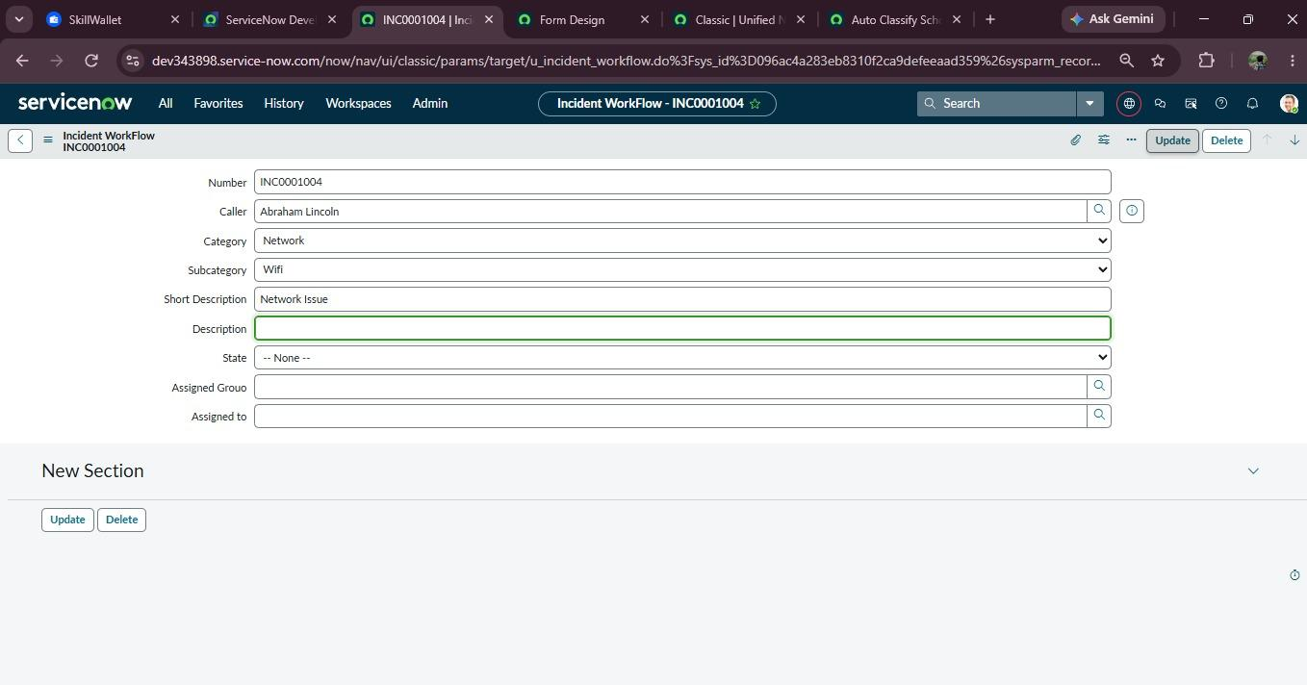
Fig 5.4

5.6 Create Flow Designer Automation

Navigation:

All → Process Automation → Flow Designer

Click:

New → Flow

Flow Name

Auto Classify School IT Tickets

Application

Global

5.7 Trigger Configuration

Trigger:

Record Created

Table:

Incident Workflow

Condition:

Category is Empty

Then click Done.

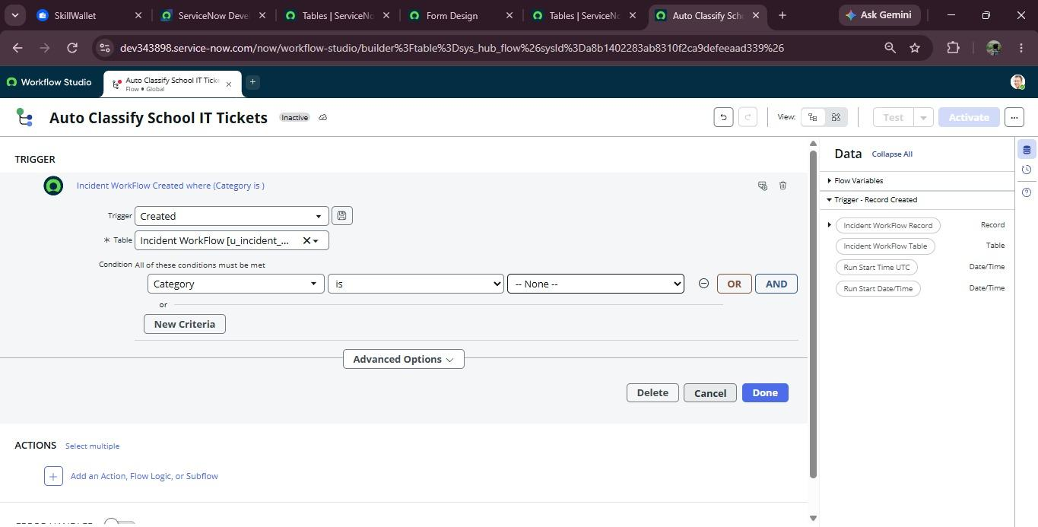
Fig 5.5

5.8 Wi-Fi Classification

Create an If condition.

Condition:

Short Description contains WiFi
OR

Short Description contains Network

Update Record:

Category = Network

Subcategory = Wi-Fi

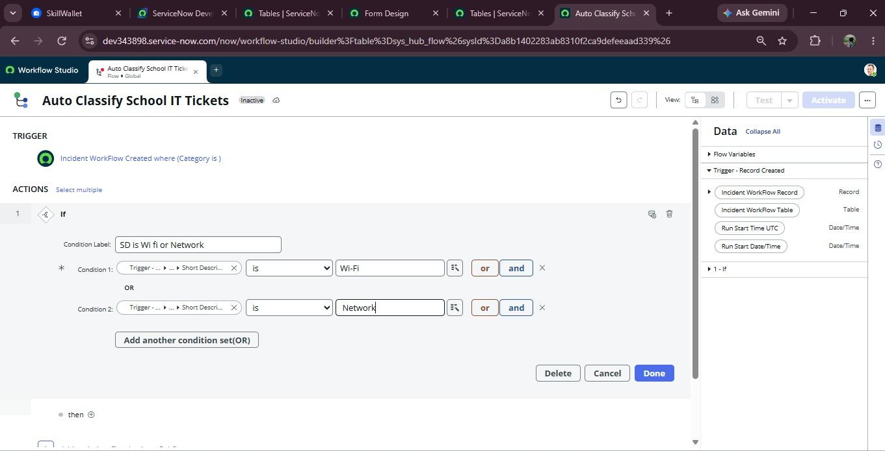
Fig Wifi condition
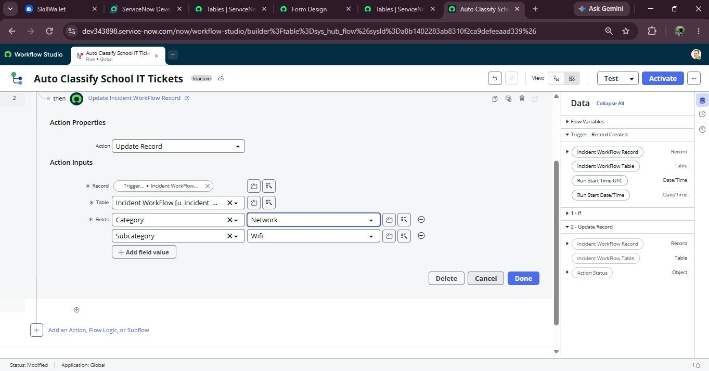
Fig update Record

5.9 Projector Classification

Create Else If.

Condition:

Short Description contains Projector

Update Record:

Category = Hardware

Subcategory = Projector

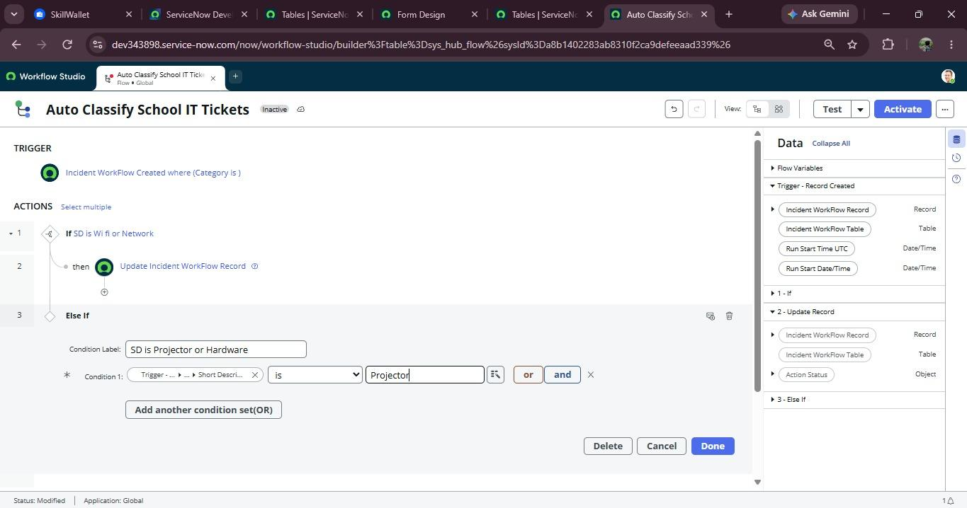
Fig 5.7

5.10 Password Classification

Create Else If.

Condition:

Short Description contains Password

OR

Short Description contains Login

Update Record:

Category = Access

Subcategory = Forgot Password

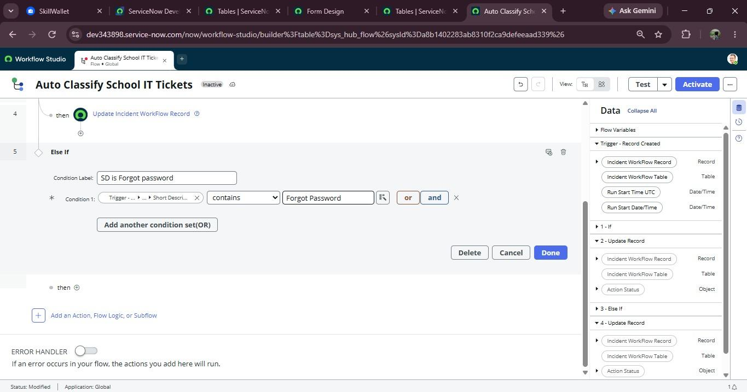
Fig 5.8
5.11 Slow Computer Classification

Create Else If.

Condition:

Short Description contains Slow

OR

Short Description contains Hanging

Update Record:

Category = Performance

Subcategory = Slow Computer

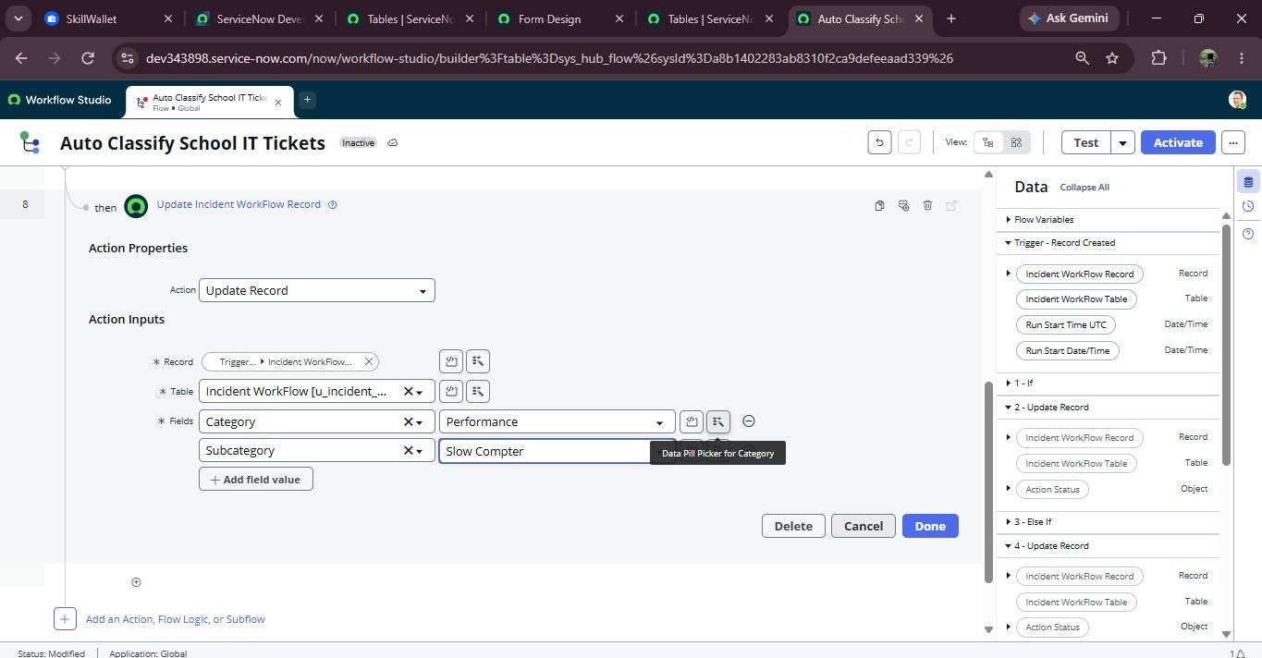
Fig 5.9

5.12 Email Notification

After classification, configure:

Action → Send Email

To

Caller → Email

Subject

Your IT Support Request Has Been Submitted

Body

Dear Caller,

Your IT support request has been successfully submitted.

Your request has been automatically classified by the IT Helpdesk system.

Our support team will review your request and take the necessary action.

Thank you,
School IT Helpdesk

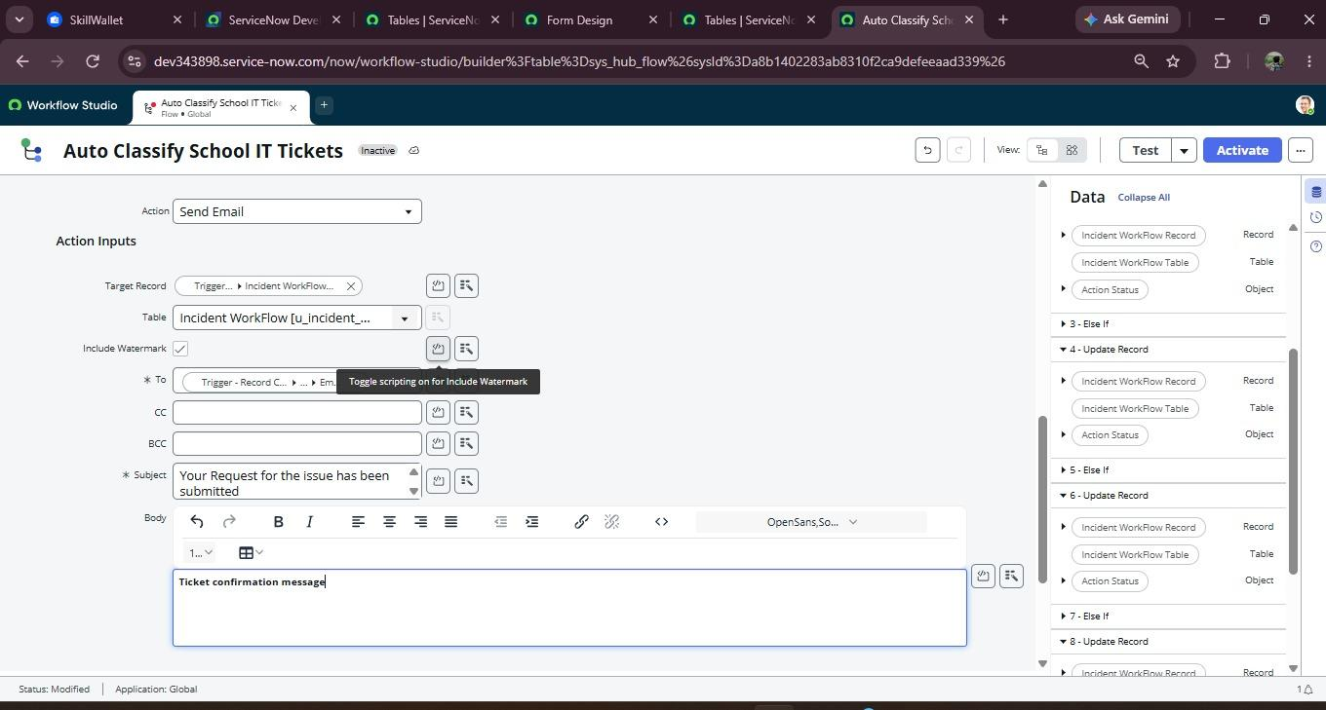
Fig 5.10

